

**Moffitt Hospital Services**

The Hillsborough County Health Care Plan has contracted with Moffitt Hospital to provide needed cancer services for our clients. Effective December 9, 2016 Moffitt Hospital will be providing the following hospital-based inpatient and outpatient medical services to HCHCP clients:

. Inclusive inpatient hospital stays, outpatient surgery services, diagnostic services, including but not limited to radiology and laboratory services, observation, and all hospital-based professional services.

. Chemotherapy and radiation therapy.

Hospital and Physician Medical Services will be provided for the following diagnoses:

1. Neuroendocrine cancer
2. Sarcoma
3. Endocrine cancers
4. Acute Leukemias
5. Triple Negative Breast Cancer
6. Mesothelioma

The list of approved diagnosis codes are listed on the Acentra Health website under the tab ‘Providers’ – tab – ‘Moffitt Dx Codes’.

Services to treat diagnoses not listed above shall be requested by the County on a case by case basis.



Acentra Health conducts medical necessity reviews on behalf of the County. Only certain CPT codes require prior authorization from Acentra Health. The list of CPT codes can be found at HCHCP.acentra.com

**Entering a referral to a Moffitt Cancer Specialist** Referral to a Specialist-follow the usual steps when entering a referral

When searching for the servicing/specialist physician for the member to seen at Moffitt Cancer Center, conduct a provider search using NPI or Name. When the search results display- select the physician with the **address listed as ‘MOFFITT CANCER CENTER’**- see example below. Click Select.

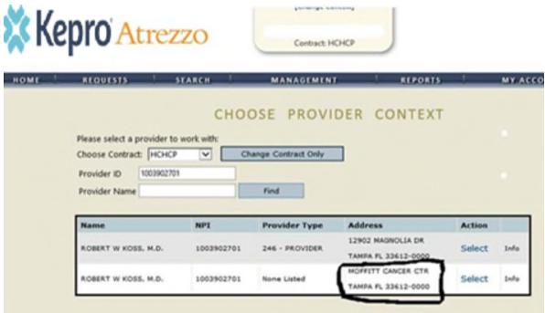

If you have any questions related to the submission of a prior authorization review, you may contact Acentra Health’s Provider Service Department at: 866-495-8388.